Ballycarry Primary School

Toileting & Intimate Care Policy

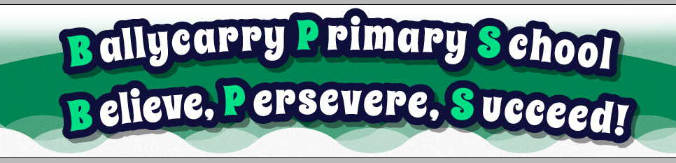

Reviewed: January 2019

School Address: 23 Hillhead Road, Ballycarry, Carrickfergus, Co. Antrim, BT38 9JH

This policy represents the agreed principles for ‘toileting and intimate care’ throughout the school. It has been agreed by all staff and governors within the school.
Definition
Intimate care is any activity required to meet the personal care needs of each individual child. Parents have a responsibility to advise staff of the intimate care needs of their child. Intimate care can include :
- Toileting
- Cleaning a pupil who has soiled him/herself or has vomited.
- supporting a pupil with dressing/undressing.
- Washing, touching or carrying out invasive procedure to intimate personal areas
- assisting a pupil requiring medical care, who is not able to carry this out unaided
- Supervision of a child involved in intimate self-care.
- Menstrual care
In most cases such care will involve cleaning for hygiene purposes as part of a staff member’s duty of care.
Principles
The management of all children with intimate care needs will be carefully planned. We are committed to ensuring that all staff responsible for the intimate care of children will undertake their duties in a professional manner at all times. There shall be a high awareness of child protection issues. The child’s safety, welfare and dignity is of paramount importance.
The issue of intimate care is a sensitive one. The child who requires intimate care is treated with respect at all times. No child should be attended to in a way that causes distress or pain.
The child will be supported to achieve the highest level of autonomy that is possible given their age and abilities. Staff will encourage each child to do as much for him/herself as he/she can.
Matters concerning intimate care will be dealt with confidentially. Each child’s right to personal privacy will be respected.
An individual intimate care plan may be drawn up for particular children as appropriate to suit the circumstances of the child. Arrangements will be discussed with parents/carers on a regular basis. The needs and wishes of children and parents will be taken into account wherever possible within the constraints of staffing and equal opportunities legislation.

Health and Safety
Staff should be aware of the school’s Health and Safety policy.
All staff must be familiar with normal precautions for avoiding infection. They must follow basic hygiene procedures and have access to protective, disposable gloves, particularly when dealing with a child who is soiled or when changing a soiled nappy.
Any soiled waste should be placed in a polythene waste disposal bag, which can be sealed or tied. This bag should then be placed in a bin (complete with a liner) which is specifically designated for the disposal of such waste. The bin should be emptied on a daily basis and it can be collected as part of the usual refuse collection service as this waste is not classified as clinical waste.
Disposable gloves and waste disposal bags are stored in the Hygiene Room.
Special Needs
Children with special needs have the same rights to safety and privacy when receiving intimate care. Additional vulnerabilities that may arise from a physical disability or learning difficulty must be considered with regard to individual care plans for each child.

Procedure for
changing children

School Record

Procedure for changing children

- The child should be changed in an appropriate manner by two members of staff (when possible).
- The child should undress him/herself and hand the items of clothing to the member of staff.
- This will take place in a private area (in the Hygiene Room if possible).
- The child will be washed and cleaned if appropriate (baby wipes are available for this purpose).
- All soiled clothing will be placed in a plastic bag and put onto the child’s coat peg to be taken home at the end of the day.
- The child will be given a change of clothing.
- Parents will be informed once the child is changed and comfortable.
- At all times the child must be made to feel comfortable and at ease with the process.

Procedure for changing children

- The child should be changed in an appropriate manner by two members of staff (when possible).
- The child should undress him/herself and hand the items of clothing to the member of staff.
- This will take place in a private area (in the Hygiene Room if possible).
- The child will be washed and cleaned if appropriate (baby wipes are available for this purpose).
- All soiled clothing will be placed in a plastic bag and put onto the child’s coat peg to be taken home at the end of the day.
- The child will be given a change of clothing.
- Parents will be informed once the child is changed and comfortable.
- At all times the child must be made to feel comfortable and at ease with the process.

______________________________ (Name of child)
was changed in accordance with the above procedure on
_________________ (Date) at ____________ (Time) by
________________________ (Member of Staff)
________________________ (Member of Staff)
School copy

Procedure for changing children

- The child should be changed in an appropriate manner by two members of staff (when possible).
- The child should undress him/herself and hand the items of clothing to the member of staff.
- This will take place in a private area (in the Hygiene Room if possible).
- The child will be washed and cleaned if appropriate (baby wipes are available for this purpose).
- All soiled clothing will be placed in a plastic bag and put onto the child’s coat peg to be taken home at the end of the day.
- The child will be given a change of clothing.
- Parents will be informed once the child is changed and comfortable.
- At all times the child must be made to feel comfortable and at ease with the process.

______________________________ (Name of child)
was changed in accordance with the above procedure on
_________________ (Date) at ____________ (Time) by
________________________ (Member of Staff)
________________________ (Member of Staff)
Parent’s copy

