Ballycarry Primary School

Anti-Bullying Policy

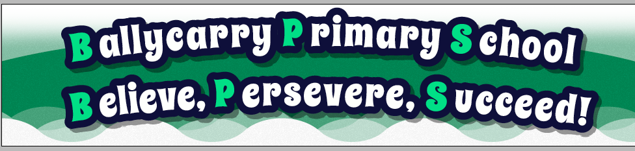

Reviewed: March 2019

School Address: 23 Hillhead Road, Ballycarry, Carrickfergus, Co. Antrim, BT38 9JH

1.1 Introduction and Definition

Bullying constitutes a form of abuse of a child by another child or young person. Bullying whether intentional or not, is repeated and continuous behaviour which makes other people feel uncomfortable, insecure or threatened.

Symptoms may include behaviour change such as:

- Withdrawal
- Lack of concentration
- Deterioration in schoolwork
- Absenteeism.

Forms of bullying can be roughly classified as:

- Physical – hitting, kicking, spitting; taking, hiding or damaging possessions.
- Verbal – threats, name calling (including sectarian, homophobic or racist name calling), teasing, insulting, writing hurtful notes.
- Emotional – being unfriendly, excluding someone from special groups, tormenting, spreading rumours, giving looks.

If unchecked, bullying can cause profound long and short term damage to the victim, emotionally, physically or both, and can seriously disrupt learning and development.

People react in varying ways to bullying, and it may not always be possible to tell if someone is hurt or upset.

In most cases, bullying would not automatically set in motion the child protection procedures.

1.2 Aims

Ballycarry is a closely knit rural community in which all members are entitled to equal rights, opportunities, respect and worth.

This anti-bullying policy is to clarify for pupils, staff and parents that bullying is completely unacceptable. We wish to encourage an environment where individuals can develop without fear. We believe that every pupil has the right to be safe from harm, to be happy in their school environs and to be protected from bullying.
1.3 Procedure

- In Ballycarry Primary School we aim to create an atmosphere where children who feel they are being bullied, or those who are aware of it, feel that they will be listened to and that action taken will be swift and firm whilst at the same time, recognising their concerns. In the light of this, it is essential that school is made aware of any suspected incidents as soon as they arise.

- Bullying is considered to be a serious offence and will be treated as such. The bully must be made aware that the behaviour is unacceptable and has caused distress. The victim must realise that revenge is not appropriate in the situation.

- Every effort will be made to resolve the problem through counselling of both parties, and, where and when appropriate, sanctions will be applied.

- Parents of both victim and the bully will be informed of the situation and also how it has been dealt with.

- If the alleged bullying behaviours persist, further action will follow. Sanctions will be considered by the Principal in consultation with the Senior Teacher or relevant teacher, taking into account the nature of the incident. Where a pupil’s behaviour is persistent and defies the school’s attempts to address it satisfactorily by behaviour management or disciplinary methods within a reasonable period of time, when the Child Protection strategies will be implemented. Counselling will continue after sanctions have been applied.

1.4 People

To Pupils:

If you regard yourself as being bullied, or, if you think someone else is, please inform a teacher immediately so that it can be dealt with. Not telling means that the victim will continue to suffer and the bully will carry on with his or her abuse. Everyone has a responsibility to make sure that bullying is not allowed in Ballycarry Primary School.

To Parents:

If you think your child is being bullied, or he/she tells you that someone else is bullied, please tell the child’s class teacher immediately. Reassure your child that the matter will be dealt with sensitively and firmly. Where it is discovered that your child is being bullied, or is directly involved in bullying, you will be contacted so that we can discuss with you how the matter may be resolved.

To Teachers

If you think bullying is happening, talk to the pupils concerned and find out what has been going on. Ask them to give a verbal or written account of the incident and make a written statement yourself in the Incident Book.

To All Staff

It is the school’s view that the most effective way of dealing with bullying is through the continued and determined action of all members of staff. Be vigilant at break and lunchtimes in the playground areas and toilets when the best opportunities for bullying are presented. Also be aware of inappropriate language or actions by pupils both inside and outside the classroom, and try to prevent such behaviour.

1.5 School Support for Anti-Bullying

- Using teaching methods which encourage cooperative work, as well as encouraging pupils to extend their relationships beyond a small group of close friends.

- Dealing with bullying as a topic to explore why it happens and suggesting varying methods of dealing with it.

This will be covered from time to time in Assembly and also through the Religious Education programme. It will also be highlighted during Anti-Bullying week.

1.6 Review

This policy will be reviewed annually by the Governors.

